Manual Testing :
Topics:
1.SDLC
2.STLC
3.Software Testing
4.Functional Testing
5.Non-functional testing
6.Test scenario and Test Case Development
7.Software Models
8.Agile Methodology
9.Defect Life Cycle
10.Jira

1.SDLC(Software Development Life Cycle):

SDLC (Software Development Life Cycle) is a structured process followed to develop high-quality software in a systematic and cost-effective way.

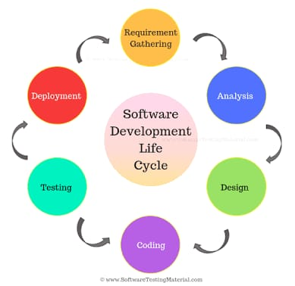

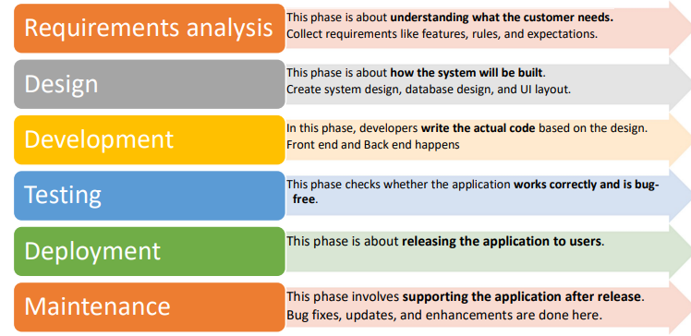
2.STLC(Software Testing Life Cycle):
STLC (Software Testing Life Cycle) is a systematic process followed by the testing team to ensure software quality.
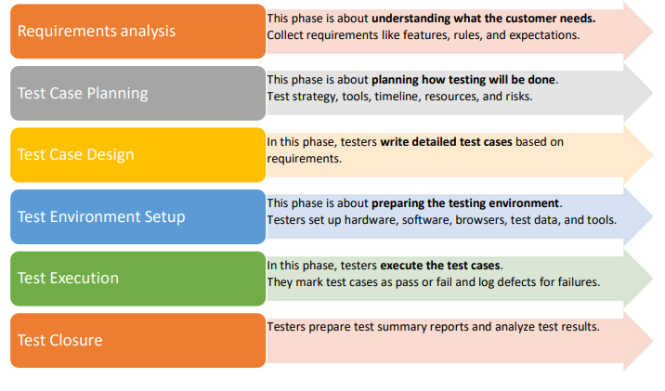

3.Software Testing:
Software testing is a process of validating and verifying a software application to ensure it meets the specified requirements and work as expected by identifying the defects.

Why Software Testing:
- To find defects early
- To ensure quality and reliability
- Reduces cost of fixing defects
- To improve customer satisfaction

Ways Of Software Testing:

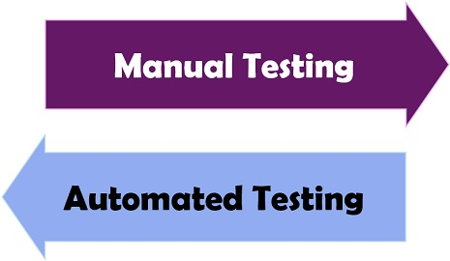

Types of Software Testing:
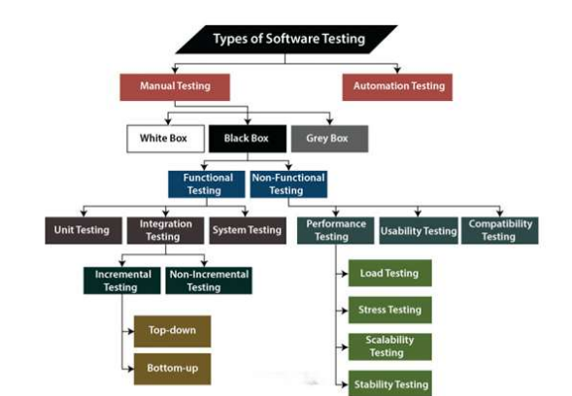
Functional Testing:
- Checks whether the application is providing all the functionalities that were mentioned in the functional requirement of the application.

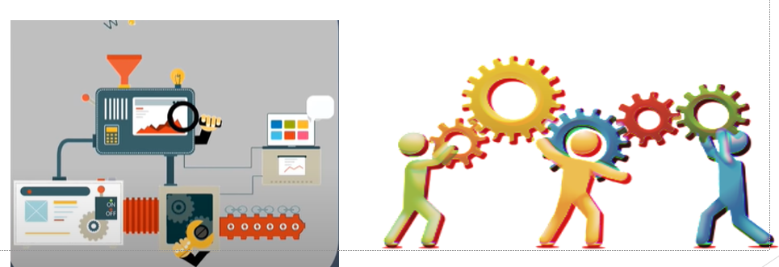

Non Functional Testing:
- To check non-functional aspects (performance, usability, reliability, etc) of a software application.
- It is designed to test the readiness of a system as per nonfunctional parameters which are never addressed by functional testing
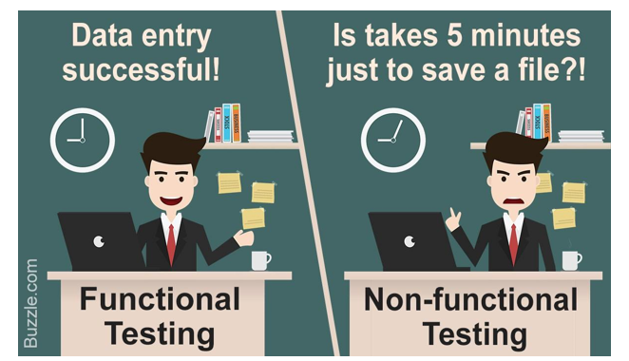
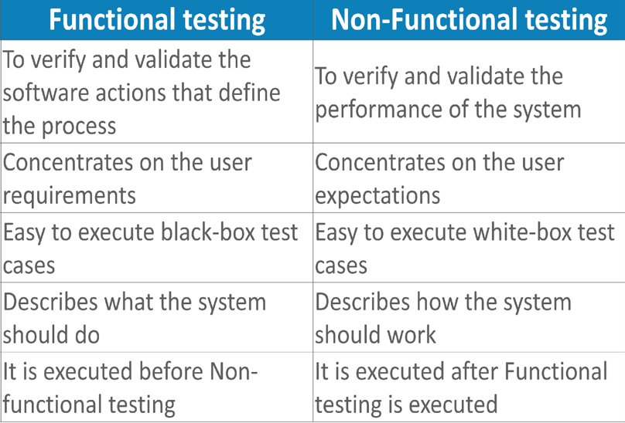

Software Testing Levels(Hierarchy):

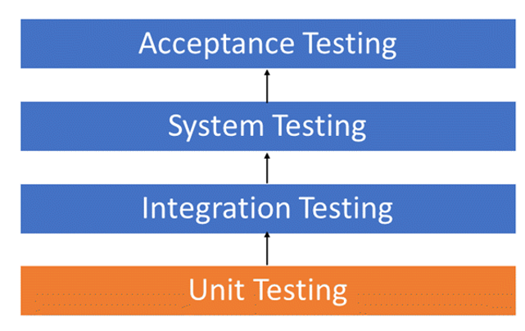

Types Of Functional Testing:
- Unit Testing
- Integration Testing
- System Testing
          - White Box Testing
          - Black Box Testing
          - Grey Box Testing
          - Smoke Testing
          - Sanity Testing
          - Regression Testing
          - Retesting
          - Localization Testing
          - Globalization Testing
          - Exploratory Testing
- Ad-hoc Testing
              - Monkey Testing
              - Gorilla Testing
              - Buddy Testing
(xi) Alpha Testing
(xii) Beta Testing
- User Acceptance Testing(UAT)

Unit Testing:
- Individual units or components of a software are tested
- It is done during the development of application by developers
- A unit may be an individual function, method, procedure, module, or object 

Integration Testing:
- Software modules are integrated logically and tested as a group
- It focuses mainly on the interfaces and flow of data/information between the modules


System Testing:
- It validates the complete and fully integrated software product
- Purpose is evaluate the end-to-end system specifications
White Box Testing:
- Testing software’s internal structure, design, and coding.
- In this type of testing, the code is visible to the tester.
- It focuses primarily on verifying the flow of inputs & outputs through the application, improving design and usability, strengthening security.

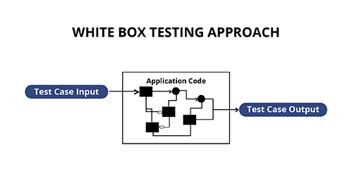

Black Box Testing:
- It is tested without looking at the internal code structure, implementation details and knowledge of internal paths of the software.
- This type of testing is based entirely on software requirements and specifications.
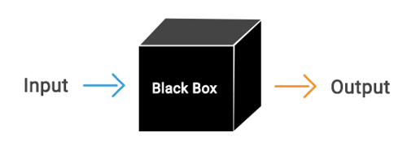
Grey Box Testing:
- Gray-box testing is a combination of white-box testing and black-box testing.
- Grey box testing is when the tester has a partial understanding of the internal structure in the system under test.
- Grey box testing is a process for debugging software applications by making an input through the front-end, and verifying the data on the back-end

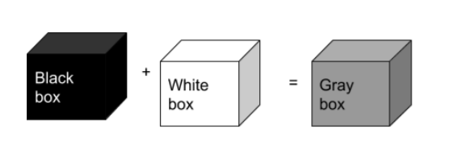
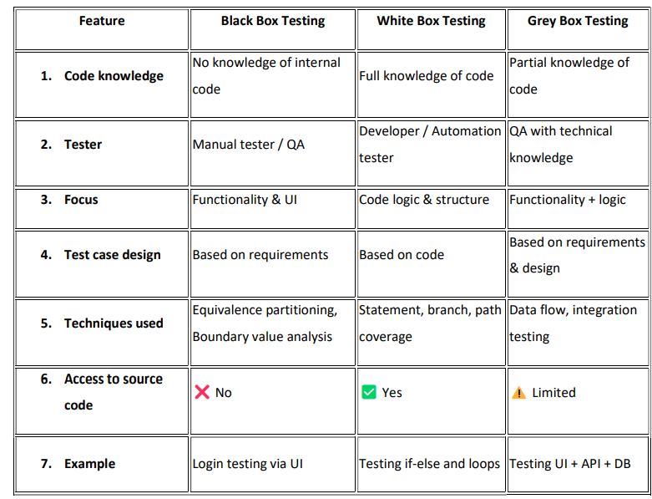

Smoke Testing:
- Smoke Testing is a type of testing performed to verify whether the basic and critical functionalities of an application are working properly.
- It is done after receiving a new build from the development team.
Purpose of Smoke Test:
- To check build stability
- To ensure critical functionality works
- To decide whether to continue further testing
When to perform Smoke Test:
- After every new build deployment
- Before starting regression testing
- After major bug fixes

Sanity Testing:
- Sanity Testing is a type of testing performed to verify that a specific bug fix or newly added functionality is working correctly.
- It is usually done after receiving a build with minor changes or bug fixes.
Smoke Testing | Sanity Testing
Done on new build | Done after bug fix
Checks basic functionality | Checks specific functionality
Broad & shallow | Narrow & deep
Verifies build stability | Verifies bug fix

Regression Testing:
- It is done to verify that a code change in the software does not impact the existing functionality of the product.
- This is to make sure the product works fine with new functionality, bug fixes or any change in the existing feature.
- Previously executed test cases are re-executed in order to verify the impact of change
When to perform Regression Testing:
- After bug fixes
- After adding new features
- After performance improvements
- After security patches
- Before a release (especially in Agile and CI/CD environments)

Selecting Test Cases for Regression Testing:
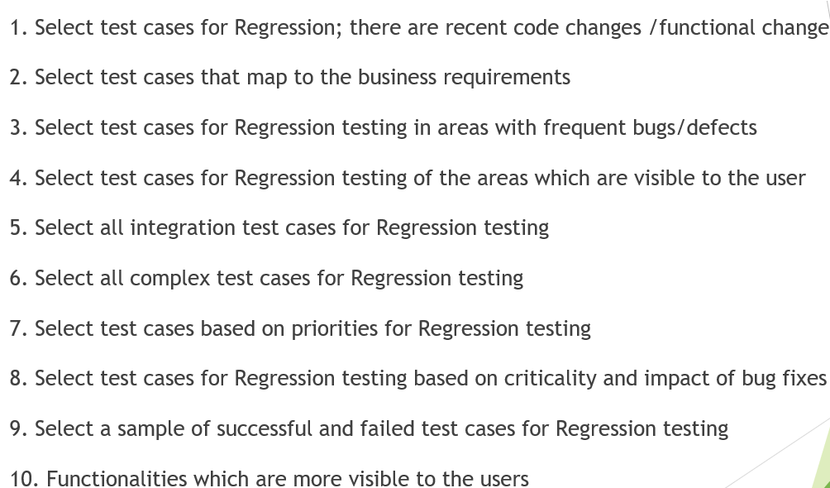
Retesting:
When a bug is reported and developers fix it, testers execute the same test case again with the same data and steps to confirm the issue is resolved.
Purpose to Perform Retesting:
- Ensure the reported defect is fixed
- Validate the fix works as expected
- Confirm no error message or incorrect behavior remains
Difference Between regression and Retesting:
Retesting | Regression Testing
Verifies a specific bug fix | Checks entire application for side effects
Focused and narrow scope | Broad and comprehensive
Executed after defect is fixed | Executed after any code change
Usually manual | Often automated

Localization Testing:
- Localization Testing is a type of software testing that verifies an application is correctly adapted for a specific country, region, or language.
- It ensures the product works properly in a particular locale (language + region settings) without breaking functionality or user experience.
- Language translation
- Date and time formats
- Currency symbols
- Number formats
- Time zones
- Cultural preferences
- Legal requirements
Example: TNPSC.
Globalization Testing:
- Globalization (G11n) means designing and developing software so it can easily be adapted for different countries and cultures.
- Supporting multiple languages
- Handling various date/time formats
- Supporting different currencies
- Accepting different character sets (UTF-8, Unicode)
- Managing time zones
- Supporting regional settings
Example: Federal bank

Exploratory Testing:
- Exploratory Testing is a type of software testing where testers learn, design, and execute test cases at the same time.
- Instead of following predefined test scripts, the tester actively explores the application to discover defects.
Why Exploratory Testing:
- Finds hidden or unexpected defects
- Useful when requirements are unclear
- Saves time when documentation is limited
- Effective for complex applications
- Helps improve test coverage
When To Perform Exploratory Testing
      - Early stages of development
      - Agile projects
      - Time-constrained releases
      - When documentation is incomplete
      - After formal testing to uncover missed bugs
Monkey Testing:
- Monkey Testing is a type of testing where the tester randomly uses the application without any specific test cases or plans to see if the system crashes.
Gorila Testing:
- Gorilla Testing focuses on testing one specific module repeatedly and thoroughly to ensure it works perfectly.

Buddy Testing:
- Buddy Testing is done by two people working together — usually a developer and a tester.

Ad-hoc Testing:
- Ad-hoc Testing is informal testing done without documentation or test cases, but unlike monkey testing, it is based on tester experience.

Alpha Testing:
- Alpha Testing is a type of acceptance testing performed at the developer’s site before the product is released to external users.
- It is conducted to identify defects before releasing the software to real customers.
Who will Perform:
- Internal QA team
- Developers
- Sometimes internal employees (not real customers)
Beta Testing:
- Beta Testing is a type of acceptance testing performed by real users in a real-world environment before the final product release.
- It is the last testing phase before the software goes live.
Who will Perform:
- Real customers
- End users
- External users (not internal employees)

4.USER ACCEPTANCE TESTING(UAT):
- User Acceptance Testing (UAT) is the final phase of testing where business users or clients verify that the software meets their requirements and is ready for release.
- It ensures the system works according to business needs, not just technical specifications.
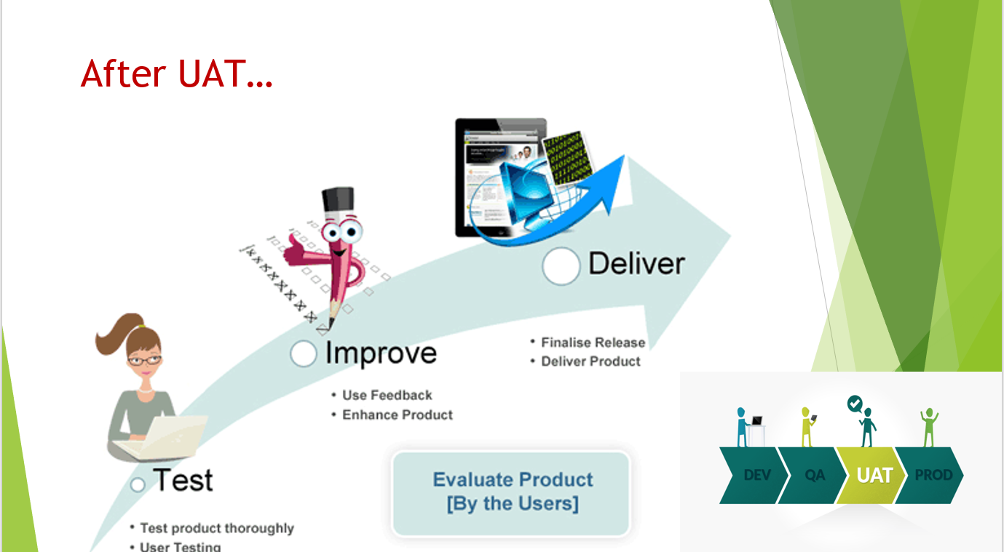

Non Functional Testing:

- Non-functional testing checks the quality attributes of the application.

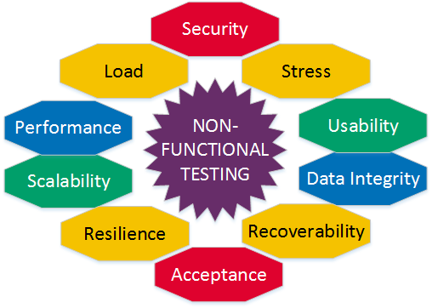

Types of Non-Functional Testing:
- Performance Testing – Checks how fast and stable the application works.
- Load Testing – Checks how the application works with expected number of users.
- Stress Testing – Checks the system behavior when the load goes beyond the limit.
- Security Testing – Checks whether the application is safe from unauthorized access and attacks.
- Usability Testing – Checks how easy and user-friendly the application is.
- Compatibility Testing – Checks if the system works equally well across different devices, browsers,and OSes.
- Recovery Testing – Verifies how the system recovers from crashes or failures.

Non Functional Testing Tools:

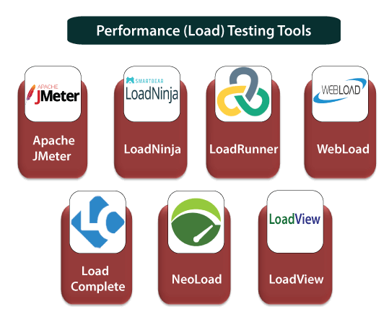
Test Scenario:

- A high-level description of what needs to be tested.
- It tells “What to test”

Example:
- Verify login functionality.
- Verify error message for invalid credentials.
- Verify “Forgot Password” feature.
Test Case:

- A detailed step-by-step procedure to test a specific functionality.
- It tells “How to test”

Test Scenario | Test Case
High-level description | Detailed step-by-step
Covers functionality | Covers validation
Less detailed | More detailed
One scenario can have multiple test cases | Derived from scenario

Test Case Template:
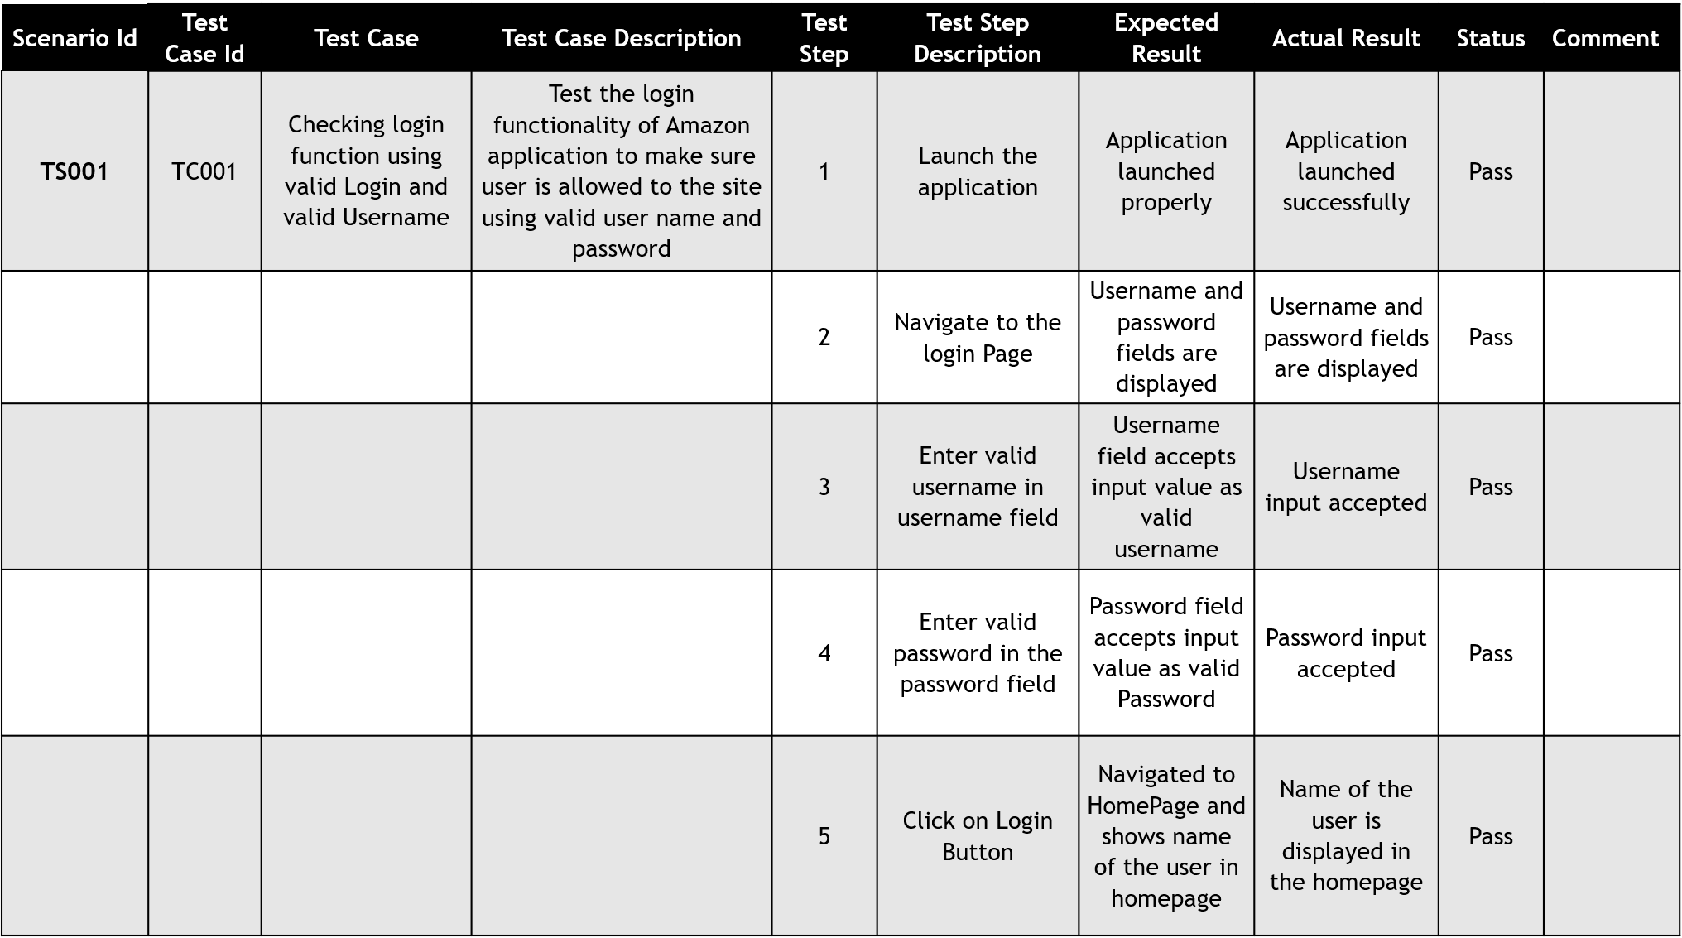
Test Strategy:

A Test Strategy is a high-level document that defines:
- Testing approach (Manual / Automation)
- Test levels (Unit, Integration, System)
- Types of testing (Functional, Regression, Performance)
- Tools used
- Risk management
- Entry & Exit criteria
It defines how testing will be done in general. Usually common for multiple projects.

Test Plan:

A Test Plan is a detailed document created for a specific project. It includes:
- Project scope
- Features to test
- Features not to test
- Test schedule
- Resource allocation
- Test environment
- Deliverables
- Risk & mitigation
It defines how testing will be executed for this specific project.

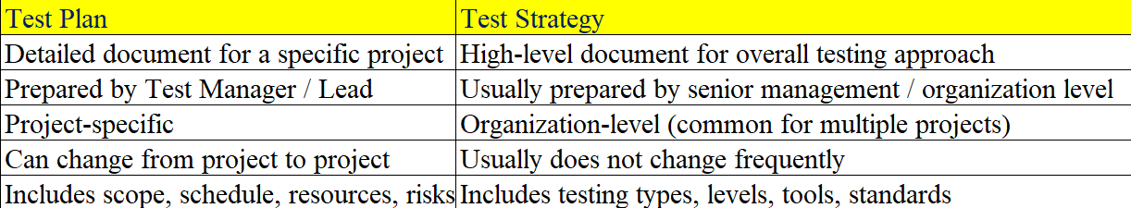

RTM(Requirement Traceability Matrix):

- RTM (Requirement Traceability Matrix) is a document used in software testing to track requirements and ensure that all requirements are covered by test cases.

It helps to verify that:
- All requirements are tested
- No requirement is missed
- All test cases are linked to requirements

Types of Traceability Matrix:

1. Forward Traceability
- Requirement → Test Case
- Ensures all requirements are covered.

2. Backward Traceability
- Test Case → Requirement
- Ensures no extra test cases exist without requirement.

3. Bidirectional Traceability
- Both forward & backward tracking.

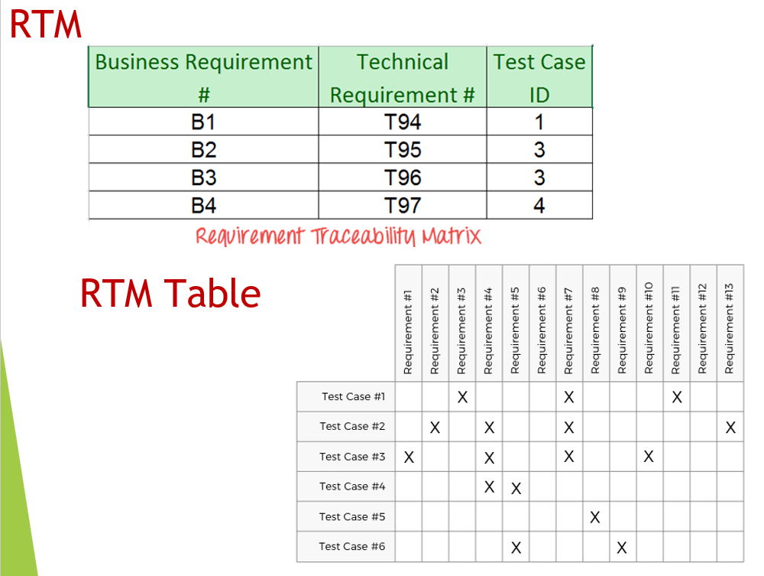

Severity and Priority:

Severity defines the impact of a defect on the application. Priority defines how urgently it needs to be fixed

Severity Levels :
- Blocker
- Critical
- Major
- Minor

Priority Levels:

- High
- Medium
- Low

1. High Severity – High Priority

- Users are unable to log in after entering correct credentials.
- User cannot register a new account.
- OTP not received during login.

2. High Severity – Low Priority

- Application crashes when user uploads a profile picture larger than 50MB.
- System fails when entering special characters in an optional “Middle Name” field.
- Error occurs when user sets system date to a future year (like 2040).
3. Low Severity – Low Priority

- Spelling mistake on login page:“Passwrod” instead of “Password”.
- Alignment issue

4. Low Severity – High Priority

- Company logo is not visible on the homepage.
- Wrong company name displayed on homepage.

Defect Life Cycle:

1. New - Tester finds and logs a defect.
2. Assigned - Test lead / manager assigns the bug to a developer.
3. Open - Developer accepts the bug and starts working on it.
4. Fixed - Developer fixes the issue and updates the status to Fixed.
5. Retest - Tester retests the application to verify the fix.
6. Closed - If the bug is fixed successfully, tester closes the bug.

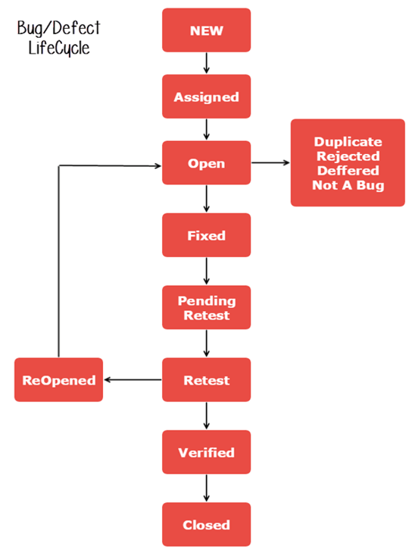

- Rejected – Bug is not valid
- Duplicate – Same bug already reported
- Deferred – Bug fix postponed to future release
- Reopened – Bug still exists after fix
- Cannot Reproduce – Developer unable to reproduce the issue

- Bug - A mistake found during testing in the application.
- Error - A human mistake made by a developer or tester while coding or designing.
- Defect - When the software does not meet the expected requirement.
- Fault - An incorrect step or logic in the code that causes a defect.
- Failure - When the application stops working or behaves wrongly during execution.
Manual Testing:

Manual testing is the process of executing test cases manually without using automation tools to find defects.

Automation Testing:
Automation testing uses tools and scripts to execute test cases automatically to improve efficiency and accuracy.

Testing Techniques:

1. Equivalence Partitioning
- Divide inputs into valid and invalid groups (partitions).
- Test one value from each partition.
- Example: If valid age is 18–60, test 25 (valid), 10 (invalid), 70 (invalid).

2. Boundary Value Analysis
- Test values at the edges of input ranges.
- Example: 17, 18, 60, 61 for an 18–60 range.

3. Decision Table Testing
- Use a table to test combinations of inputs and resulting actions.
- Useful for complex business rules.

4. State Transition Testing
- Test system behavior when moving between states.
- Example: Login → Failed login → Account locked.

5. Use Case Testing
- Based on real user scenarios.
Software Models:

1.WaterFall Model
2.Spiral Model
3.V & V Model
4.Protype Model
5.Agile Model

Waterfall Model:

A linear and sequential approach.

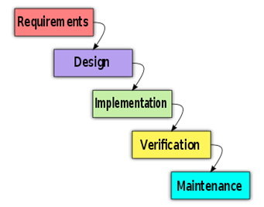

Advantages:

Simple and easy to manage
- Well-documented

Disadvantages:
- Not flexible to requirement changes
- Testing happens late
Best suited for: Small projects with fixed requirements.

Spiral Model:
Combines iterative development with risk analysis.
Each cycle involves:
- Planning
- Risk analysis
- Engineering
- Evaluation

Advantage:
- Good for large, high-risk projects

Disadvantage:
- Complex and costly
ProtoType Model:
- Build a prototype first.
- Refine based on user feedback.
V &V Model:
An extension of Waterfall where testing is planned in parallel with development.
- Each development phase has a corresponding testing phase.
- Emphasizes validation and verification.

Advantage:
- Early test planning
- Better quality control

Disadvantage:
- Still rigid like Waterfall
Verification checks documents to prevent defects, while Validation checks the application to detect defects.

Verification | Validation
Static testing | Dynamic testing
No code execution | Code execution
Done on documents | Done on application
Prevents defects | Finds defects

Agile Model:

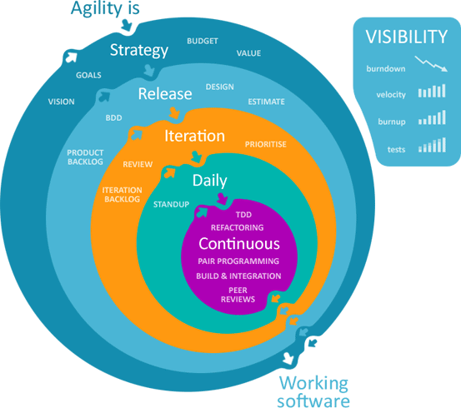

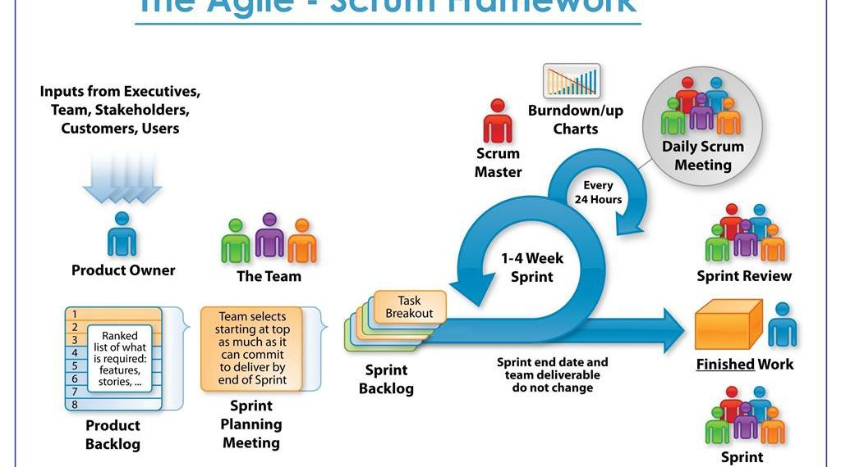

- It is a practice that promotes continuous iteration of development and testing throughout the software development lifecycle of project.
- Both Dev and testing activities are concurrent unlike Waterfall model
Agile emphasizes on 4 core values:
- Individual and team interactions over processes and tools
- Working software over comprehensive documentation
- Customer collaboration over contract negotiation
- Responding to change over following a plan

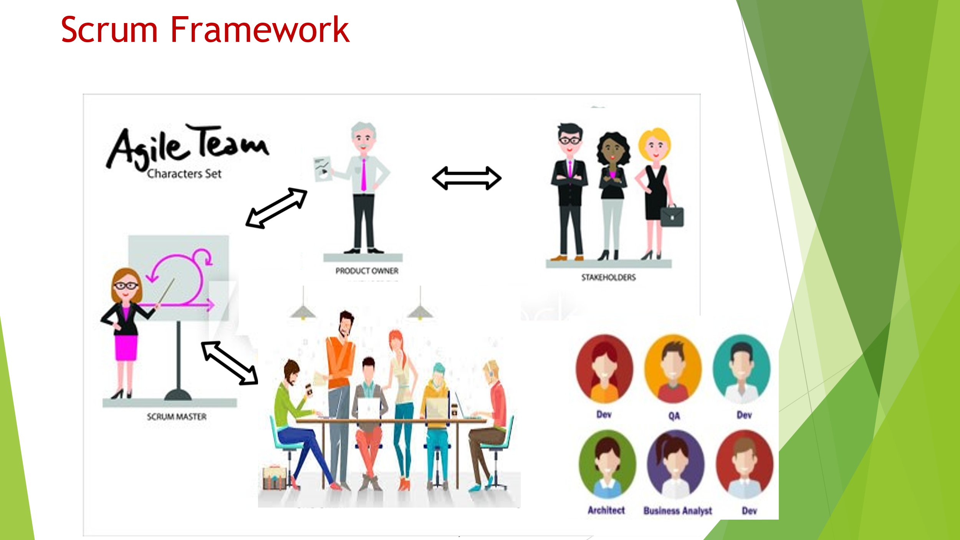

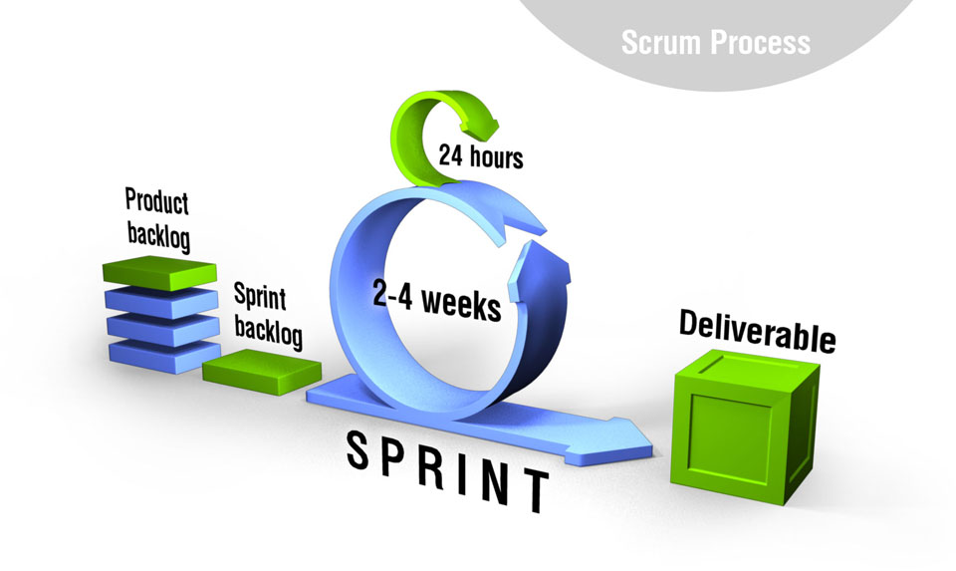

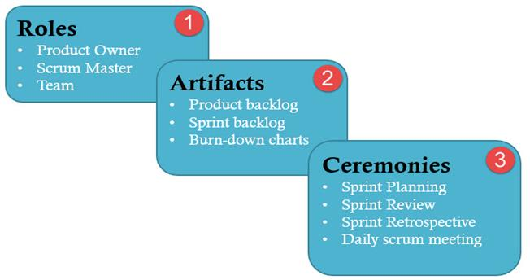

Scrum Master:

- He setting up the team and look after the team’s productivity
- Invites to the daily scrum, sprint meetings
- Removing obstacles to progress
- Coordinates with all roles and functions

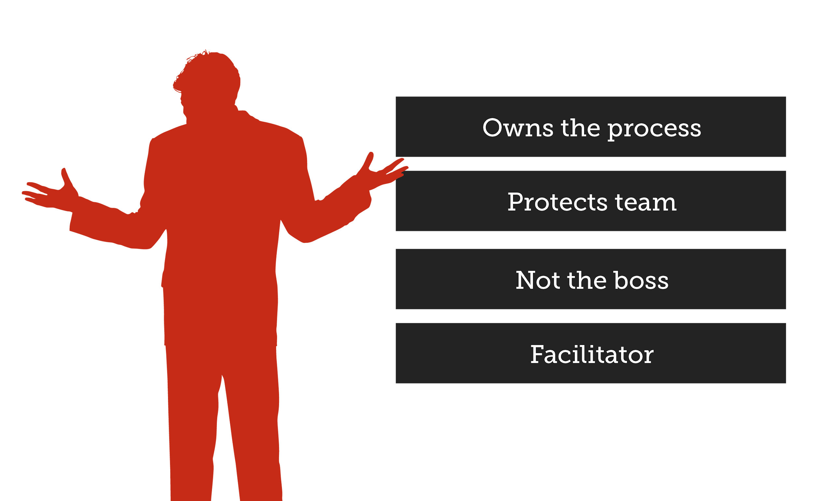

Scrum Team:
- Manages its own work
- Organizes the work to complete the sprint or cycle





Product Owner:

- He defines features of the Product
- Creates product backlog
- Decides the release date and corresponding features
- Prioritizes the backlog (features) according to the market value
- Getting delivery of the functionality at each iteration from scrum team

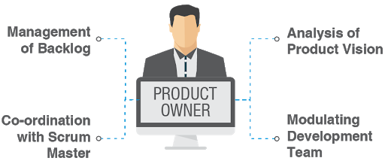

Sprint :
- It is a set period of time to complete the user stories, decided by the product owner and developer team, usually 2-4 weeks of time.

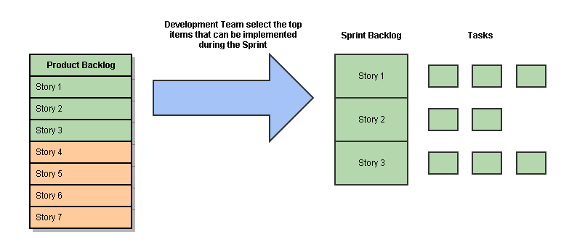
Product Backlog:
- This is a repository where requirements are tracked with details on the no of requirements (user stories) to be completed for each release.
- It should be maintained and prioritized by Product Owner, and it should be distributed to the scrum team.
Sprint Backlog:
- It is a set of user stories to be completed in a sprint
- During the sprint backlog, work is never assigned, and the team signs up for work on their own.
- It is owned the estimated work remaining is updated daily.
- It is the list of task that has to be performed in sprint

Burn Down chart:

A Burndown Chart is a graphical representation used in Agile projects (especially Scrum) to show how much work remains versus time.
Example:

Work
Remaining
|
|\
| \
| \ ← Ideal Line
| \
| \__
| \___ ← Actual Line
|
|_________________________
Time (Days)
Sprint Duration: 10 days
Total Work: 100 story points
- Day 1 → 100 points
- Day 5 → 60 points
- Day 10 → 0 points
If the actual line is:
- Above ideal → Project is behind schedule
- Below ideal → Project is ahead of schedule

User Stories:
- They are short explanation of functionalities of the system under test

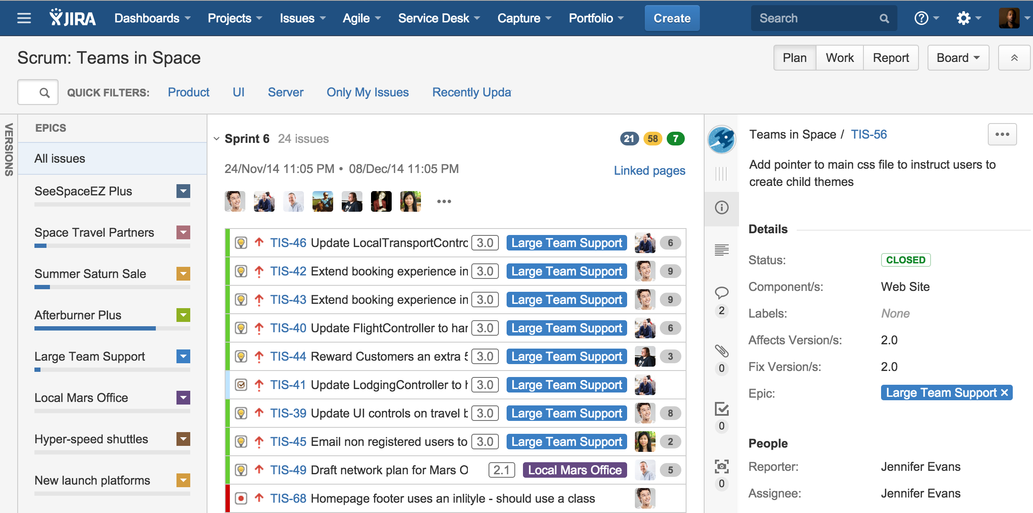

1.Sprint planning Meeting:
- Tester should pick a user story from product backlog that should be tested
- Tester should decide how many hours (Effort Estimation) it should take to finish testing for each of selected user stories.
- As a tester, He/she must know what sprint goals are.
- Tester should contribute to the prioritizing process


2. Daily scrum meeting:
- Client, (Product owner)
- Scrum Master, (Lead)
- Dev Team,
- Automation Team
- Functional Team (Manual)
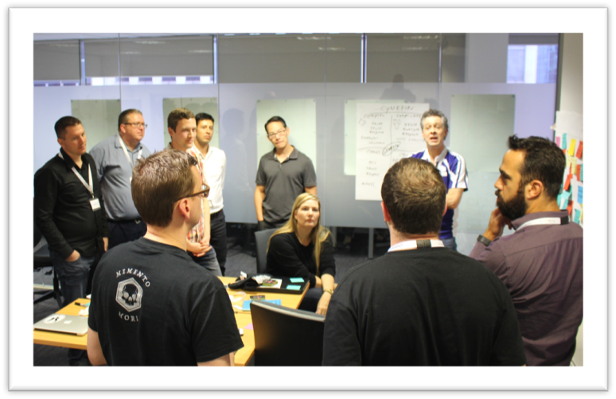

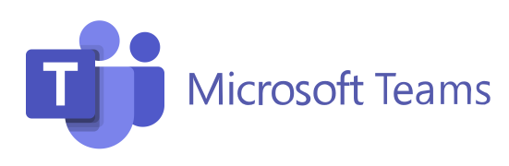

3.Sprint Review meeting:
- The sprint review is an informal meeting which the development team, the scrum master, the product owner and the stakeholders will attend.
- The team gives a demo on the product and will determine what are finished and what aren’t.
- It is mandatory to deliver a potentially shippable product increment at the end of every Sprint. So, Sprint Review meeting is held at the end of each Sprint.

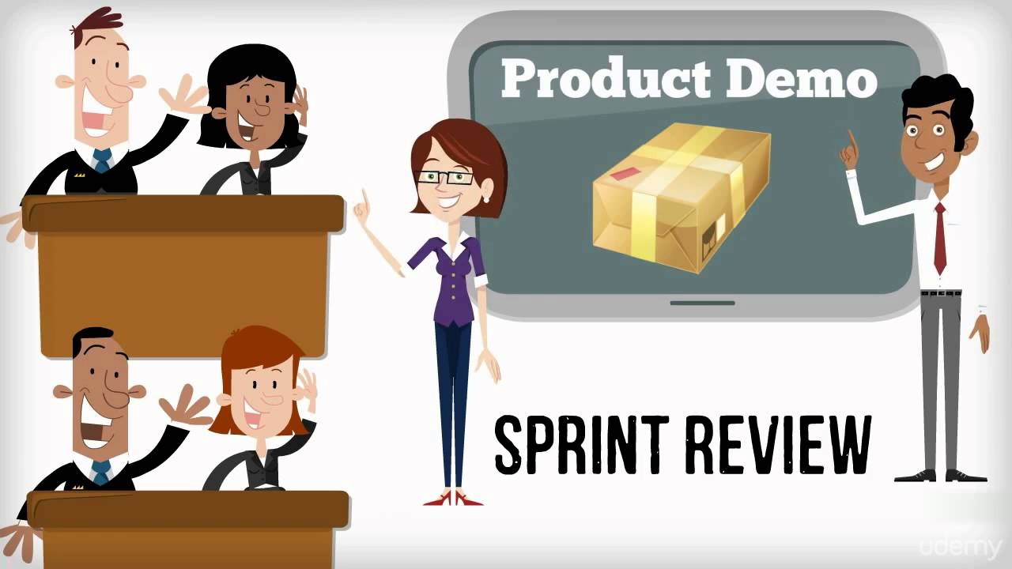

4. Sprint Retrospective Meeting
- As a tester, He will figure out what went wrong and what went right in current sprint
- As a tester, He identifies lesson learned and best practices.



JIRA: 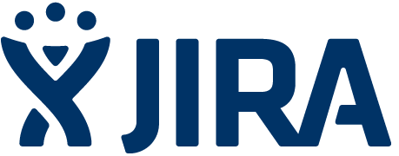
Defect Tracking Tool
To create a issue,
- Project : Name of the Project
- Issue Type : Bug/Epic/Story/Task/Subtask/New Feature
- Summary : One line summary
- Description : Details of the issue
- Priority : High/Medium/Low/Lowest
- Labels : Specific type of issue
- Issue(Related To) : User can link the Issue ID to the linked issue
- Assignee : Who is responsible to fix this issue.
- Epic Link : If the issue belongs to any of those Epic Link
10.Sprint : In which Sprint, this issue addressed

